##### **ST.PETER’S COLLEGE BUWEERA**

##### **BEGINNING OF TERM I EXAMS 2024**

##### **S.4 GEOGRAPHY PAPER I**

##### **DURATION: 2 Hours.**

**INSTRUCTIONS: Attempt ALL questions in both sections**

**SECTION A**

1. (a) Tororo 45o East of the prime meridian while Seatle city lies 100o West

of the meridian. If it is 7:00am (GTM) at Tororo, what time is it at Seatle?

(2 scores)

(b) Many people argue that the earth does not move. As a geography student who has knowledge of the earth, how can you prove to such people that really the earth moves? (3 scores)

2. What do you understand by the term a river? (2 scores)

(b) Outline any two features found in each section of a river profile. (6 scores)

(c) Choose one of the features in b above and describe how it was formed. (3 scores)

3. a) Identify three main features associated with spilling waves. (3 scores) (a)

(b) Describe how any two features identified in (a) above were formed (8 scores)

(c) Imagine your family migrated and settled along the East African coast, Explain;

(i) Four advantages they would enjoy while at the coast (4 scores)

(ii) Four disadvantages they would face while at the coast (4 scores)

**SECTION B**

1. Study the photograph provided below and respond to the tasks that follow.

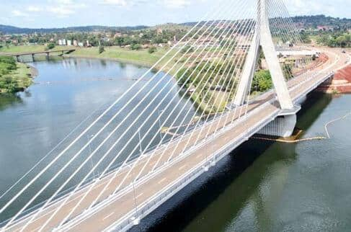

(a). Identify the type of photograph above. (1 score).

(b) Draw a landscape sketch of the photograph and on it mark and name. (5 scores)

(i) Bridge

(ii) Drainage feature

(iii) Two types of vegetation

(iv) A hill

(c) State any two economic activities that can take place in the area shown on photograph. (2 scores)

(d) How harmful is the above drainage feature in the photograph to man. (3 scores)

(e) By giving a reason for your answer, suggest any one area in East Africa where the above photograph could have been taken from. (2 scores)

2. Study the Uganda map extract of Pakwach provided and respond to the following tasks.

(a) What is the scale of the map? (1 score)

(b) State the six figure grid reference of the;

(i) Trigonometric station (1 score)

(ii) Kanyigo lodge (1 score)

(c) Suppose the government of Uganda is giving out the forest to an investor for investment. Each square kilometer (square km) is given out at a cost of 10,000 dollars per month for a period of 7 years.

i). Establish the area of the forest in square kilometers and find out how much

the investor will pay the government for a period of 7 years. (6 scores)

(ii) Using the knowledge of map work, explain how you would locate the trigonometric station from Kanyigo lodge using bearing. (4 scores)

(iii) Explain various reasons why the area around the forest may not be suitable for human settlement. (3 scores)

(iv) Suppose the government has given you a contract to lay a pipe from the river Easting to Pakwach town. Estimate the length of the pipe line and the total cost of piping if each kilometer of the pipeline cost 2 million Uganda shillings. (4 scores)

(d) Outline the problems the people to Pakwach would face as a result of the

governments’ decision to give away the forest to an investor. (3 scores)

3. For any one fieldwork study you have carried out on either on a market or a trading center,

(a) State the:

(i) Topic of your study (2 score)

(ii) Objectives of your field work study. (3 score)

(b) Draw a sketch map of the area studied and on it mark and label (5 score)

(i) Physical features,

(ii) Man-made features

(c) Describe the preparations you made for your field work study (3score)

(d) Explain the problems faced by the people living around the area of your field work

study. (2 score)

**END**